
Final Exam – Computer Vision 2025

1 h 30 – No document allowed (11 questions counting for 21 points)

Student First name : _________________________ Family name: _________________________

Part 1: Short Answer / Epipolar geometry.
Ans: See correction from https://web.stanford.edu/class/cs231a/syllabus.html

Write your answer to each question in the space below it. You may only need to write a short answer that does not fill up the space.

Let's imagine that we have 8 corresponding points between the left and the right images shown below (each pair of corresponding points (p_{l} vs p_{r}) is illustrated by a different color).
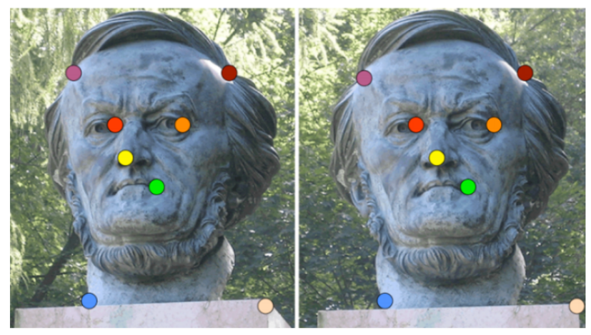

Now let's imagine that two pairs of the points were incorrectly matched, as with the orange and red points below (the points on the right and left eyes of the statue):
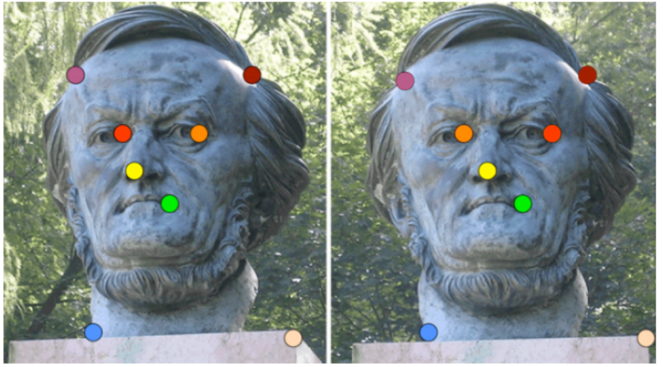

Question 1 (2 points – 10 mn): Would the epipoles of the images stay the same? How about the epipolar lines of each of the 4 points in these two pairs of incorrect matches? Explain why or why not.

Ans: The epipoles stay the same, since they are a function of the camera origin and not points on the images. The epipolar lines corresponding to the points that got swapped will change, since the pixel coordinates of the points changed. Also acceptable to say all epipolar lines changes because the epipolar plane changes, or say epipolar lines dont change because those pixels locations stay the same and we just change the labels of the points.
Question 2 (2 points – 10 mn): We know the eight points algorithm is built around the constraint that p_{r}^{T} F p_{l} = 0. Why would this constraint no longer be true for the two incorrectly matched pairs of points? Explain in terms of P, p_{r}, and p_{l}, and the epipolar plane (you can use plain English, equations are not required).

Ans: The equation p_{r}^{T} F p_{l} = 0 holds because p_{l} lies on l_{r} and p_{r} lies on l_{l}, i.e. p_{l} and p_{r} are co-planar with P. Likewise, equation p_{r}^{T} F p_{l} = 0 holds because p_{l} lies on l_{r} and p_{r} lies on l_{l}, i.e. p_{l} and p_{r} are co-planar with P. Here epipolar lines are parallel (the images are rectified), i.e. between left and right views there was a translation only. p_{l} and p_{l} lies on the same line l_{r} meanwhile p_{r} and p_{r} lies on the same line l_{l.} Same translation was applied to p and p on the left view, so their coordinates should be not shifted on the right view.

Question 3 (2 points – 10 mn): Now let's assume all the correspondences are correct, as in the first stereo images, and we know the camera's extrinsics and intrinsics for each view. Could we find these points' locations in 3D space? If so, how? Describe the simplest method, assuming there is no noise.

Ans: The simplest method is to find the intersections of the lines from O_{l} to P and O_{r} and P (triangulation process).

Part 2: Short Answer / Single-View Reconstruction.
Ans: See correction from https://web.stanford.edu/class/cs231a/syllabus.html

Write your answer to each question in the space below it. You may only need to write a short answer that does not fill up the space.

Suppose you are given one camera image of a person standing next to the leaning tower of Pisa. The person's height is unknown but the standing height of the leaning tower (the tallest point to the ground) is known to be 55.86 m. The height of one of the levels (highlighted as A) is known to be 5.8m.

Question 4 (1 point – 5 mn): Given only one image and the absolute height of the tower and its levels, is it possible to reconstruct the height of the person standing next to it? What additional information, if any, would be needed to compute the exact person's height?

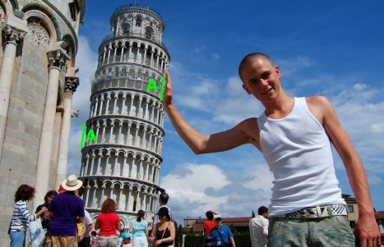
Ans: No. You would need information about the distance from camera to the tower and person.

Question 5 (1 point – 5 mn): Suppose the intrinsics of the camera to be zero-skew and unit aspect ratio (that is, square pixels). Flipping the problem now, assume the length of the person's hand to be 20cm (0.2m). Given his hand is the same length as the height of one of the levels in the image (5.8m), what is the relative amount of magnification between the plane the person is standing at relative to the plane of the tower? (Hint, use the weak-perspective camera model).

Ans: Relative magnification = 5.8/0.2 = 29, i.e. the person appears 29x bigger relative to the background tower.

Question 6 (1 point – 5 mn): Construct the formula for computing the distance to the tower from the camera knowing the distance of the person to the camera (2m). (Let us assume that the camera center to be C, and that the camera has a focal length of 1).

Ans: 2m / X = 0.2/5.8 = 1 / 29, so X = 58 (principle of similar triangles)

Question 7 (1 point – 5 mn): Suppose the camera does not have the canonical zero-skew unit aspect ratio. How many parallel lines from the image (and their corresponding vanishing points) are needed to compute the camera's intrinsic parameters? Why?

Ans: 4 pairs of parallel lines, 3 only solves for zero-skew unit aspect ratio

Part 3: Short Answer / Structure-from-Motion.

Write your answer to each question in the space below it. You may only need to write a short answer that does not fill up the space.

In the Structure-from-Motion problem, we can reconstruct the 3D geometry of the scene and camera parameters using multi-view correspondences. Let us assume that the focal is constant.
A Euclidean transformation is defined by 6 DOF.

Question 8 (1 point – 5 mn): Given 11 camera views, what is the minimum number of points needed to solve the Euclidean Structure-from-Motion problem?

Ans: m = number of camera views. n = number of 3D points. For affine SfM, we want 2mn (number of 2D projections in all images) > 6m (6 DOF per view) + 3n. Given m = 11, we have 22n > 66 + 3n, n > 66/19, thus we need at least 4 points.

Part 3: Epipolar Geometry.
Write your answer to each question in the space below it. You may only need to write an answer that does not fill up the space.

Consider the stereoscopic arrangement of pinhole cameras shown in Figure 1. The two pinhole cameras of parallel optical axes Z_{l} and Z_{r}, with projection centres O_{l} and O_{r}, and focal length F are separated by a distance (baseline) T along axis X. The image of a object point P is x_{l} in the left image plane and x_{r} in the right image plane.

Figure 1
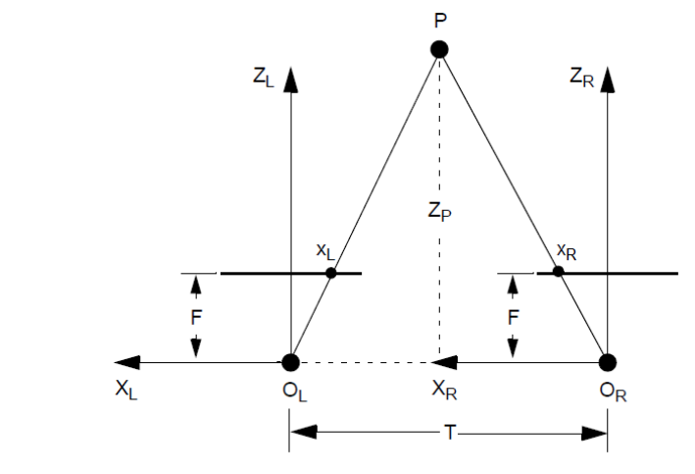

The stereo disparity between the images of point P is defined as follows:
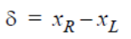 (1)

Question 9 (2 points – 10 mn): Show that the distance Z_{P} from point P to the line connecting O_{l} to O_{r} (i.e. the distance between P and the baseline) is given by:
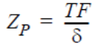 (2)
Explain your answer.

Ans:
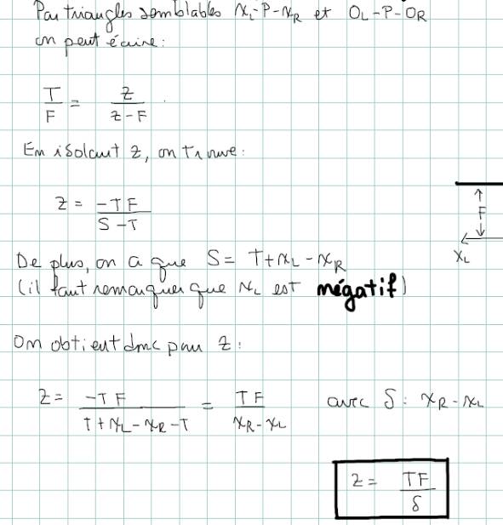

Let the origin of the framework 'world' be located at the projection center of the camera on the left, such that T = 1m according to x (the translations according to y and z are nil) and such that the matrices of the intrinsic parameters of the camera on the left and on the right of Figure 1 are given, respectively, by:
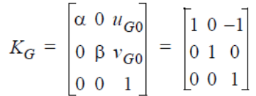 (3)
and
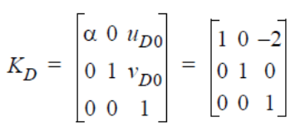 (4)

Question 10 (4 points – 20 mn): Give the expression of the fundamental matrix of this stereoscopic arrangement.

Recall that if:
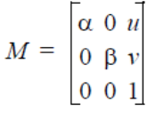 (5)
then M⁻¹ is defined by:
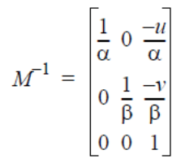 (6)

Ans:
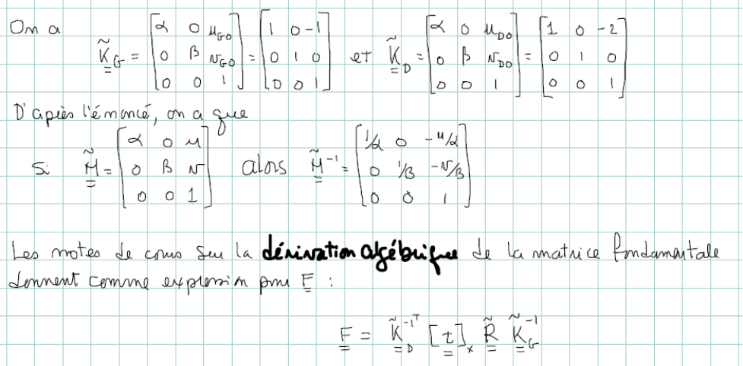

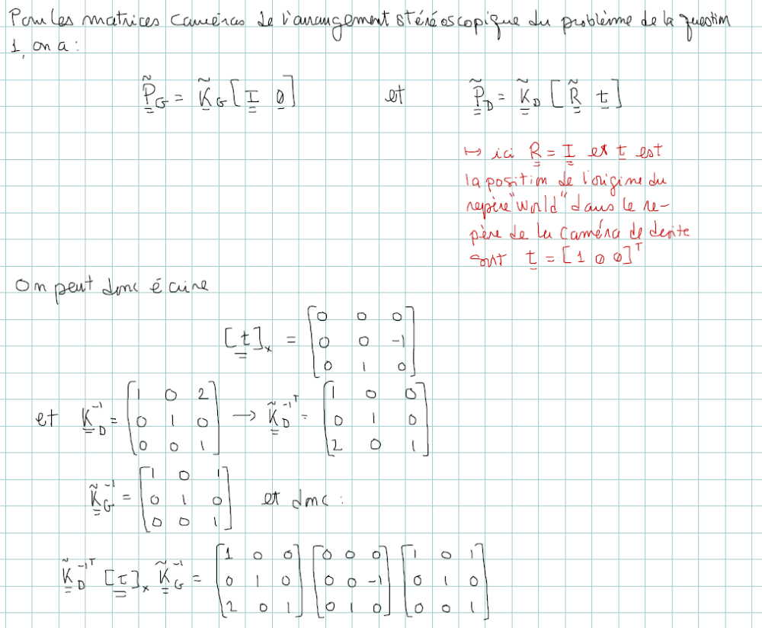
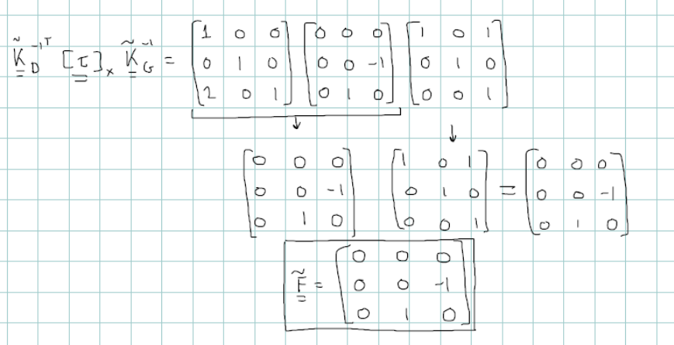

Question 11 (4 points – 10 mn): Let the images on the left and on the right of Figure 1 have a resolution of 640 x 480 pixels.
i) How many epipoles does the image on the right have?
ii) Where are these epipoles located?
iii) How many epipolar lines does the image on the right have?
iv) What are the characteristics of these epipolar lines with respect to the lines of the image on the right?

Ans:
